**Project Design Phase-II**

**Data Flow Diagram & User Stories**

|  |  |
| --- | --- |
| Date | 17 October 2022 |
| Team ID | PNT2022TMID02664 |
| Project Name | Smart Waste Management System For Metropolitan Cities |
| Maximum Marks | 4 Marks |

**Data Flow Diagrams:**

A Data Flow Diagram (DFD) is a traditional visual representation of the information flows within a system. A neat and clear DFD can depict the right amount of the system requirement graphically. It shows how data enters and leaves the system, what changes the information, and where data is stored.

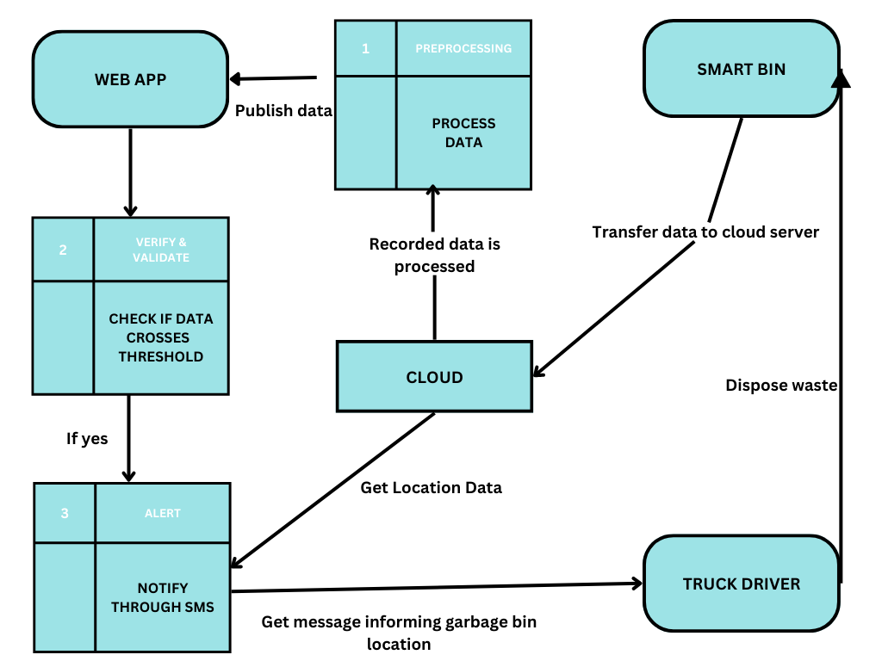

**User Stories**

| **User Type** | **Functional Requirement (Epic)** | **User Story Number** | **User Story / Task** | **Acceptance criteria** | **Priority** | **Release** |
| --- | --- | --- | --- | --- | --- | --- |
| Customer (Web application user) – Municipality employee | Registration | USN-1 | As a user, I can register for the application by entering my employee ID, email, password, and confirming my password. | I can access my account / dashboard | High | Sprint-1 |
|  | Confirmation | USN-2 | As a user, I will receive confirmation email once I have registered for the application | I can receive confirmation email & click confirm | High | Sprint-1 |
|  | Login | USN-3 | As a user, I can log into the application by entering email & password | I can login to the application and access the dashboard. | High | Sprint-1 |
|  | Dashboard | USN-4 | As a user, I can access all resources in the dashboard. | I can have access to all the features. | High | Sprint-2 |
|  | Monitoring | USN-5 | As a user, I can monitor the status of the smart bins. | I can now see the bin’s garbage level, weight and its location. | High | Sprint-2 |
|  | Alerting | USN-6 | As a user, I can alert the truck drivers to clear trash by sending the location of bin as SMS. | I can send notification alerts to truck drivers. | High | Sprint-2 |
| Customer (General Public) | Viewing | USN-7 | As a user, I can view the status of smart bins at various locations. | I can view information on smart bins without registering. | Medium | Sprint-3 |
| Administrator | Creates and maintains | USN-8 | As an admin, I can create and maintain all information about the bins. | I have full access to the application without any access permit. | High | Sprint-3 |
|  | Provide credentials | USN-9 | As an admin, I can provide or revoke login credentials to the municipality employees. | I can view the status of their login and logout. | Medium | Sprint-3 |
|  | Add/Remove/Update smart bins in a locality | USN-10 | As an admin, I can add, remove or update any bins in that locality into the system. | I have full accessibility and permission to incorporate or remove bins in the system. | High | Sprint-3 |